**Model Development Phase Template**

|  |  |
| --- | --- |
| Date | 15 March 2024 |
| Team ID | 740009 |
| Project Title | Student Adaptability Level of Online Education |
| Maximum Marks | 10 Marks |

**Initial Model Training Code, Model Validation and Evaluation Report**

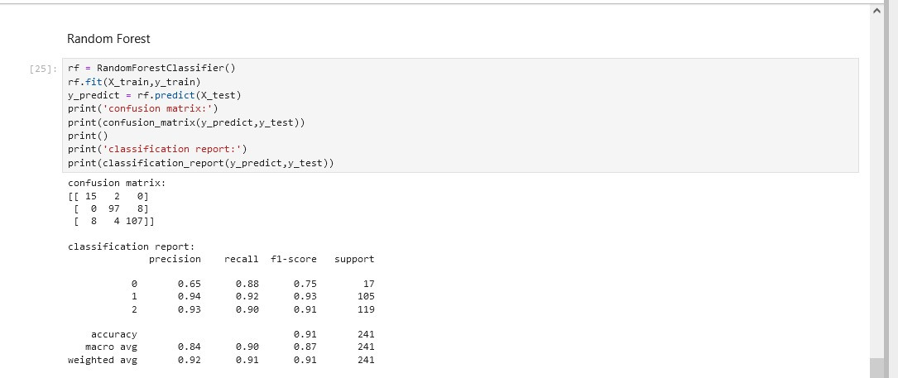

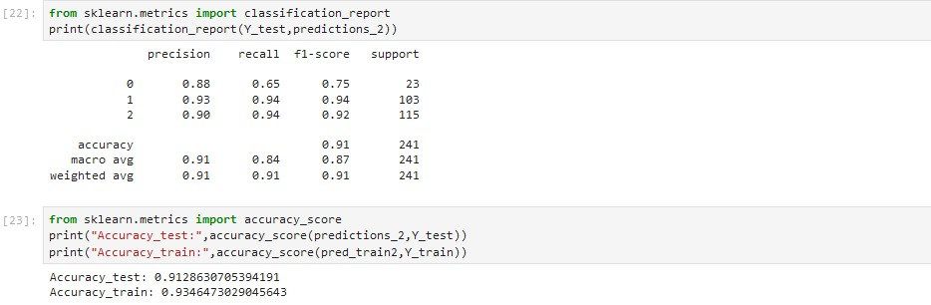

**Initial Model Training Code (5 marks):**

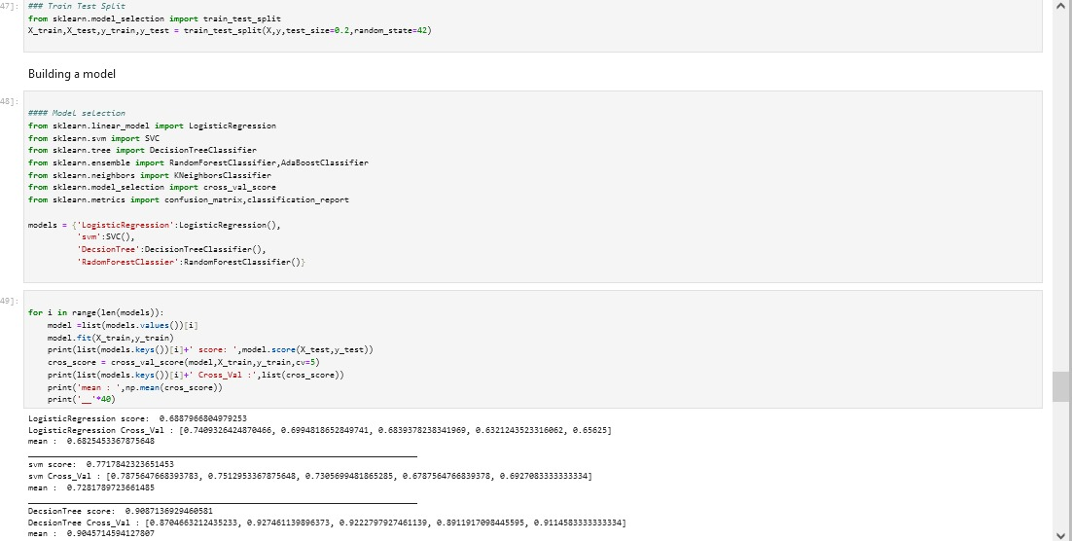

**Model Validation and Evaluation Report (5 marks):**

|  |  |  |
| --- | --- | --- |
| **Model** | **Summary** | **Training and Validation Performance Metrics** |
| Random Forest Classification | A function named random forest regressor is created and train and test data are passed as the parameters, inside the function, random forest regressor is initialized and training data is passed to the model with the .fit() function. Test data is predicted with .predict () function and saved in a new variable. For evaluating the model with R2_score. |  |
| Decision Tree Classification | A function named decision tree regressor is created and train and test data are passed as the parameters, inside the function, decision tree regressor is initialized and training data is passed to the model with the .fit() function. Test data is predicted with .predict () function and saved in a new variable. For evaluating the model with R2_score. |  |
| Xg Boost | A function named xg boost is created and train and test data are passed as the parameters, inside the function, Gradient boosting regressor is initialized and training data is passed to the model with the .fit() function. Test data is predicted with .predict () function and saved in a new variable. For evaluating the model with R2_score. |  |